**MD5 Collision Attack**

**Karan Amrutesh**

***Question 1****. If the length of your prefix file is not multiple of 64, what is going to happen?*

* Taking a prefix file whose size is not a multiple of 64:

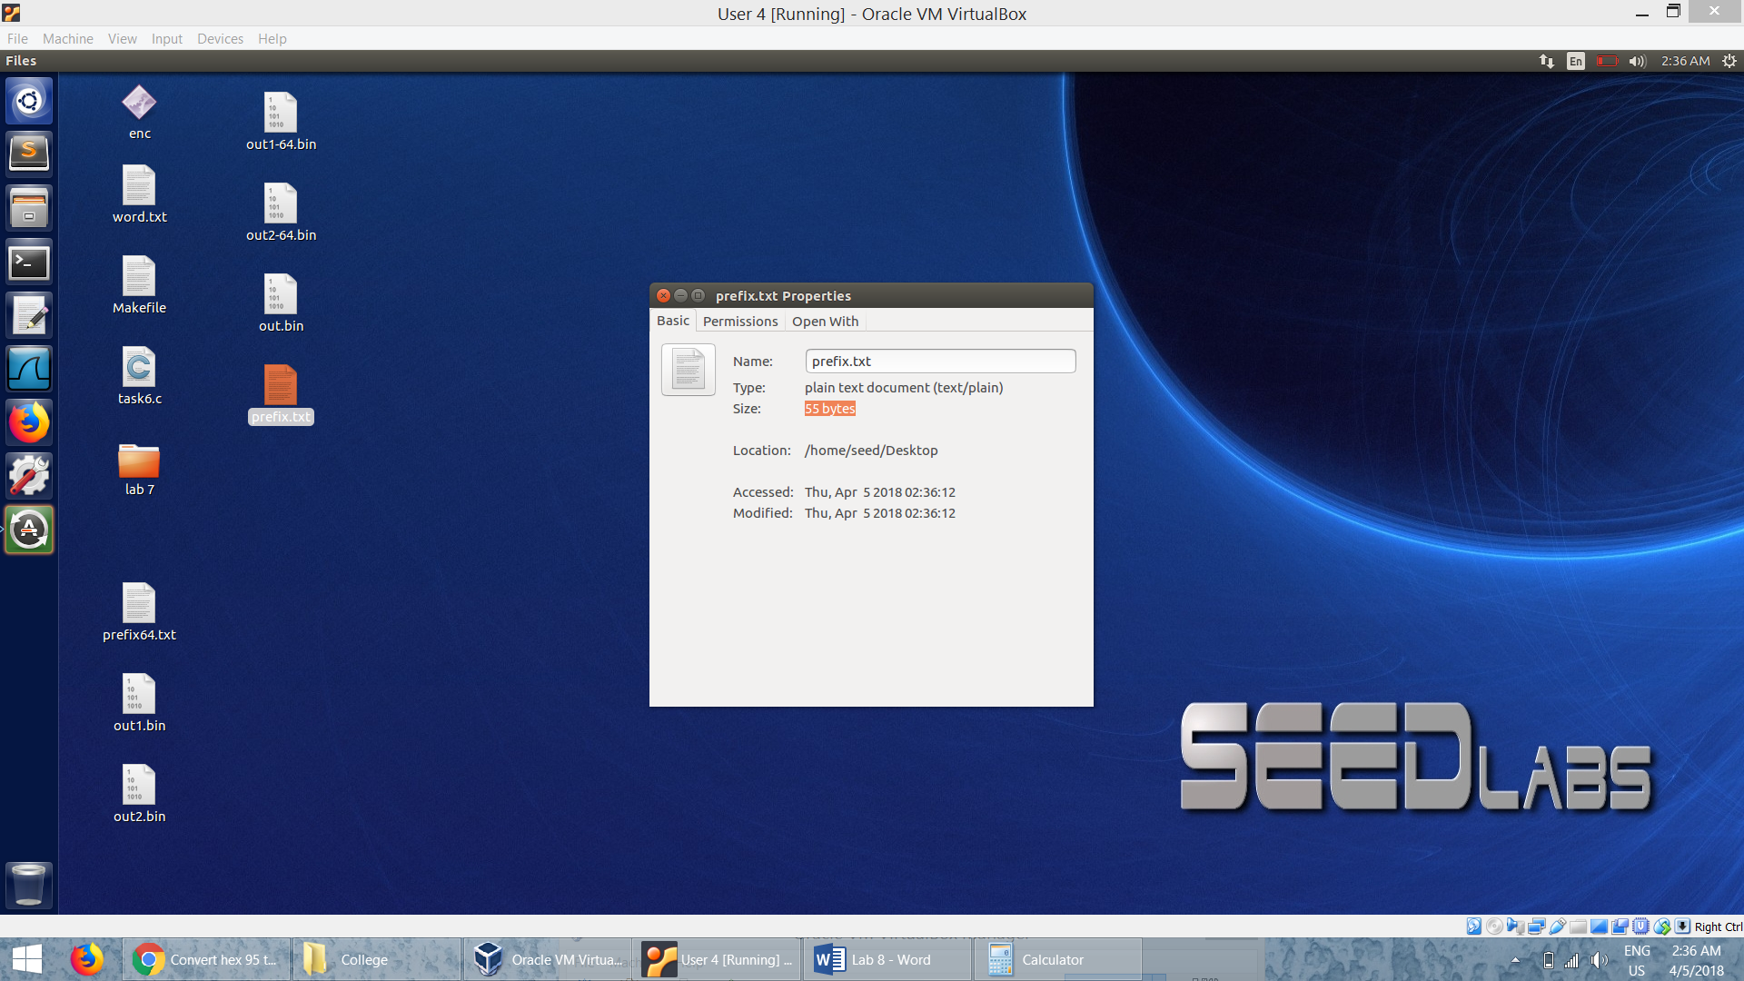

* We run the md5collgen program with the given prefix file:

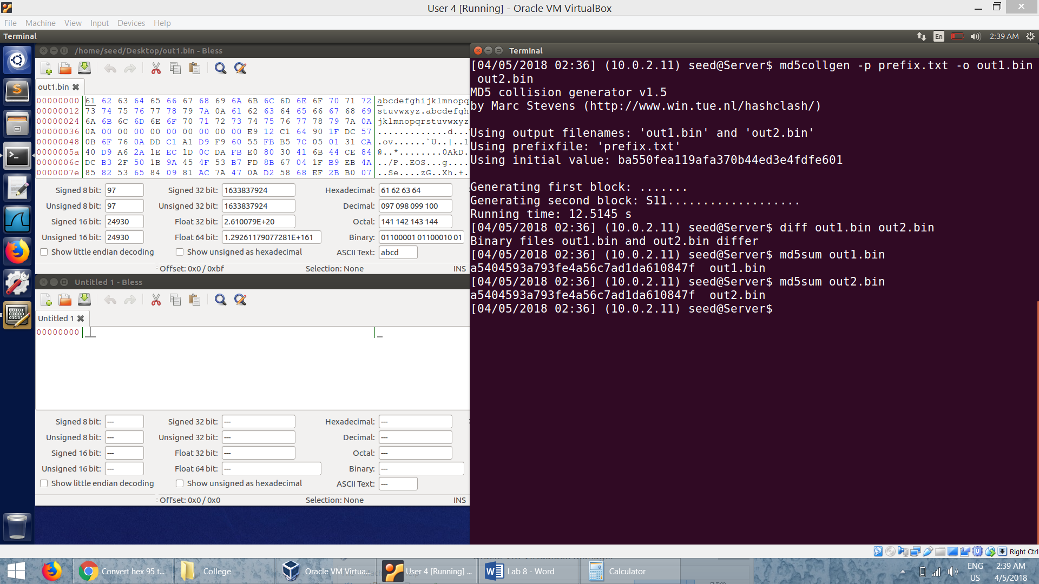

* In the hex files of the output files from the md5collgen program, we can see that padding is added as the length of the prefix is not a multiple of 64.

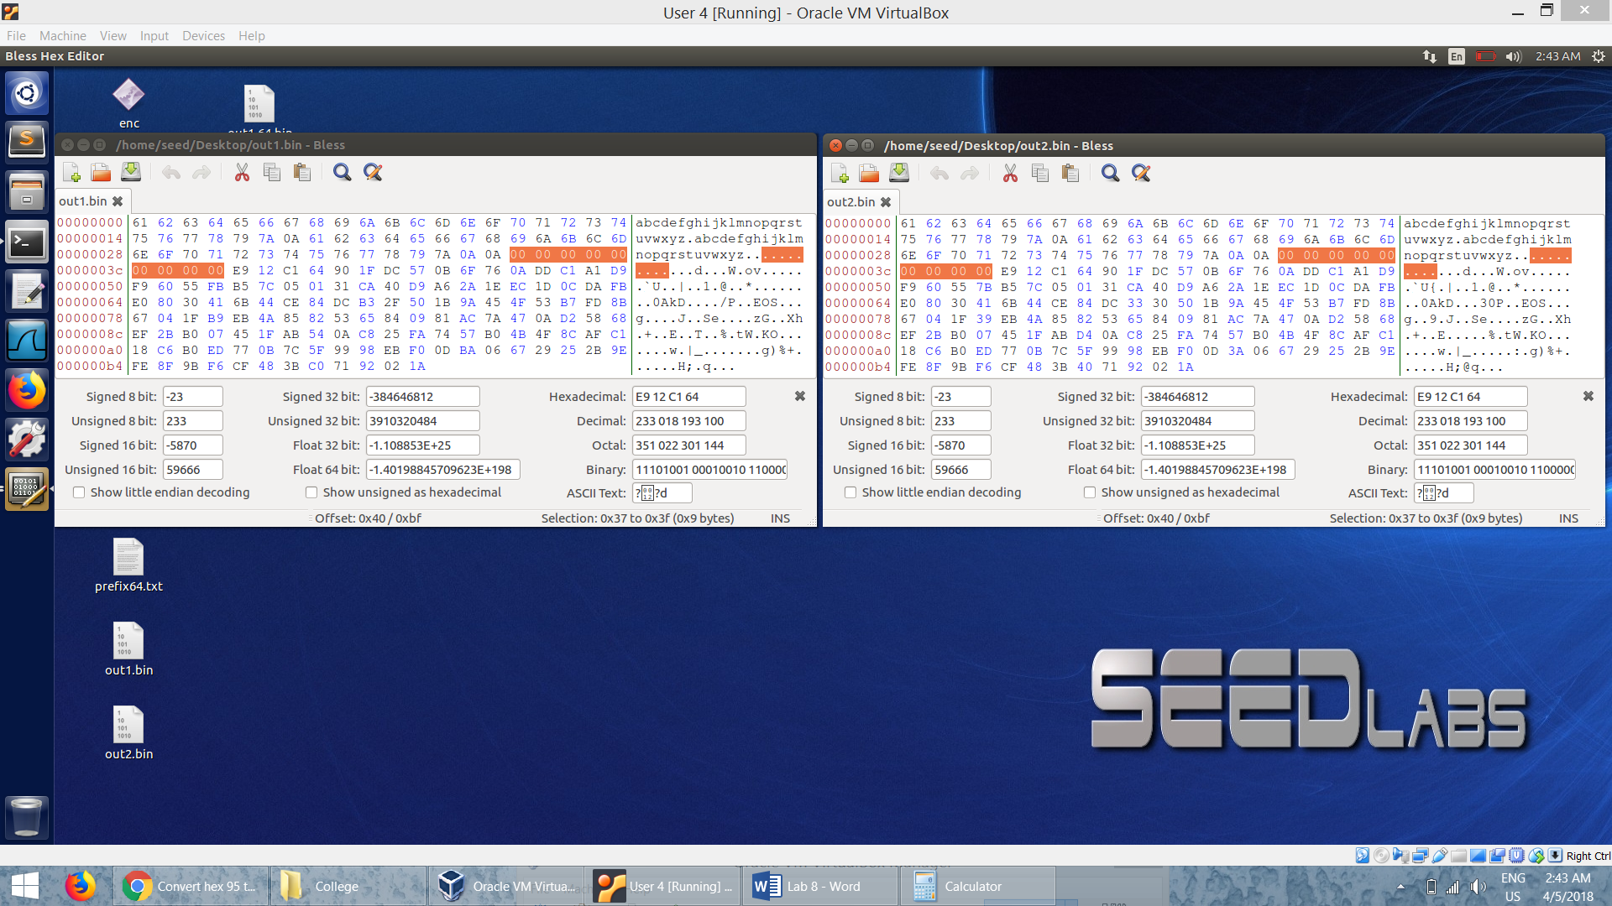

* The differences in the two output files as seen in the *Bless:*

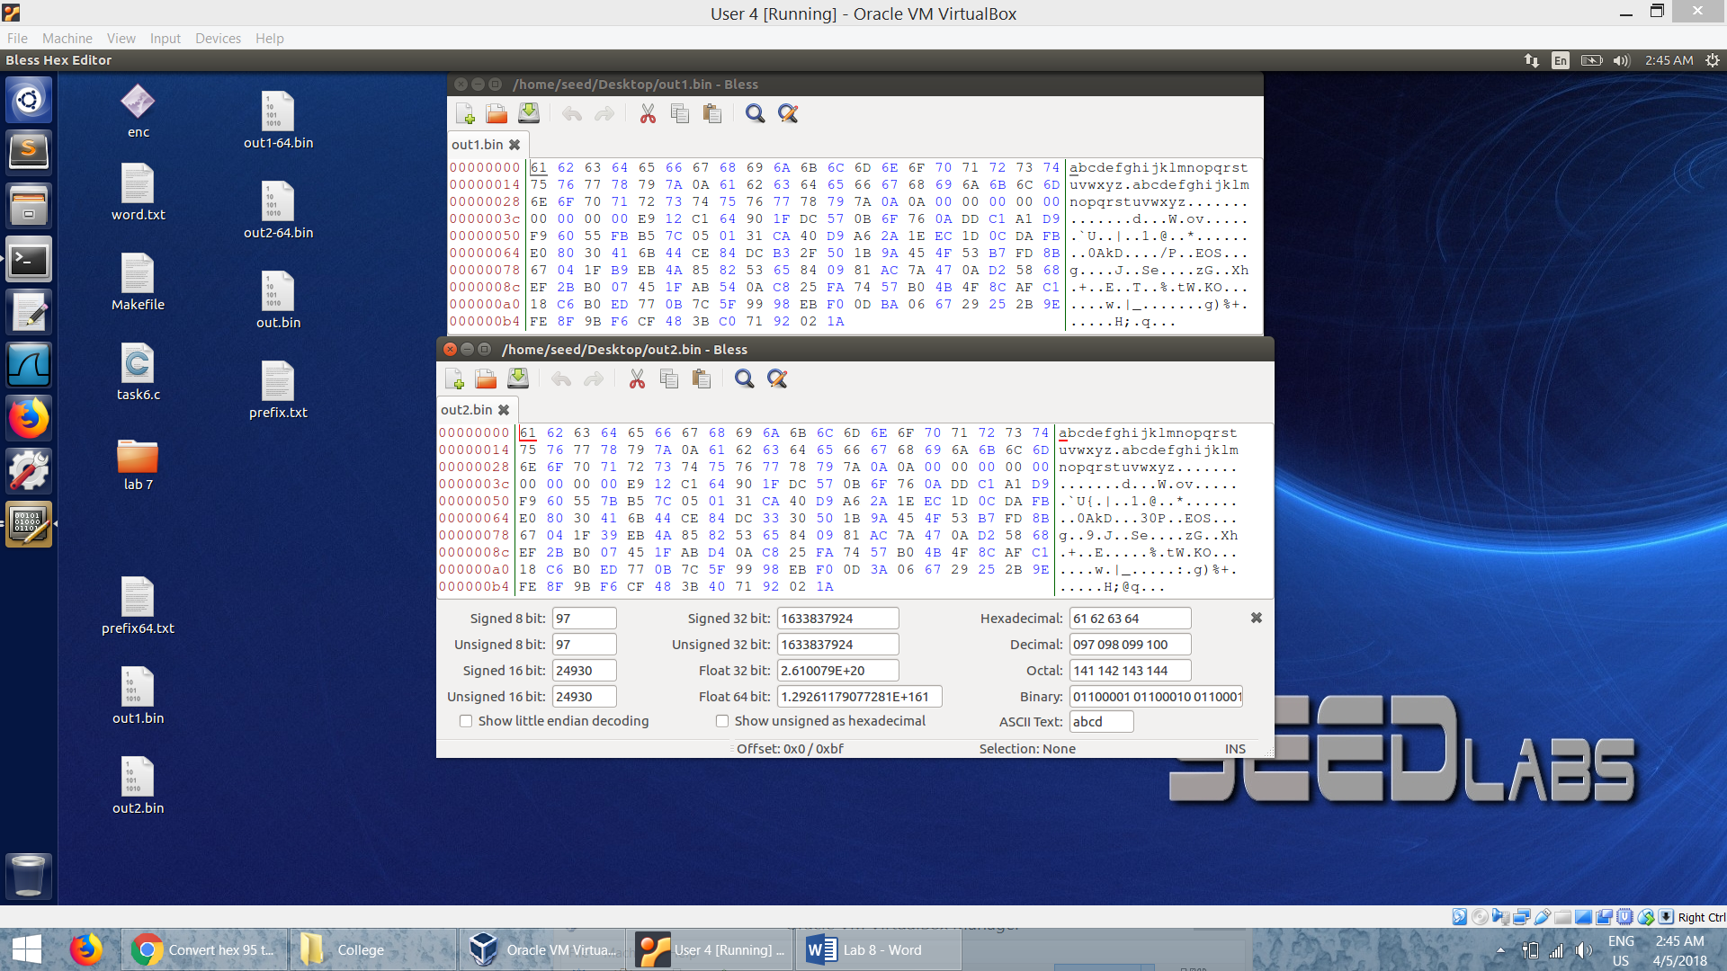

* We can also see that the two output files are different using the *diff*  command:



* But from the MD5 hash produced by the md5sum command. We can see that their MD5 hash values are the same

***Question 2:*** *Create a prefix file with exactly 64 bytes, and run the collision tool again, and see what happens.*

* Taking a prefix file whose size is exactly bytes:

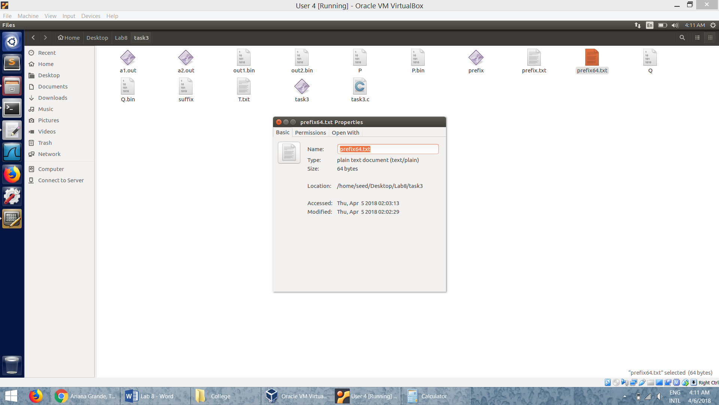

* We run the md5collgen program with the given prefix file:

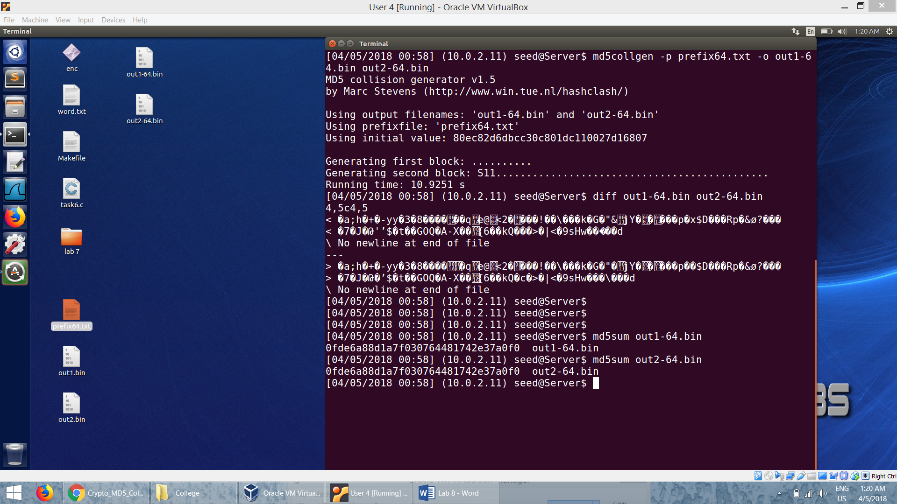

* We can see that no padding is added in the output files generated:

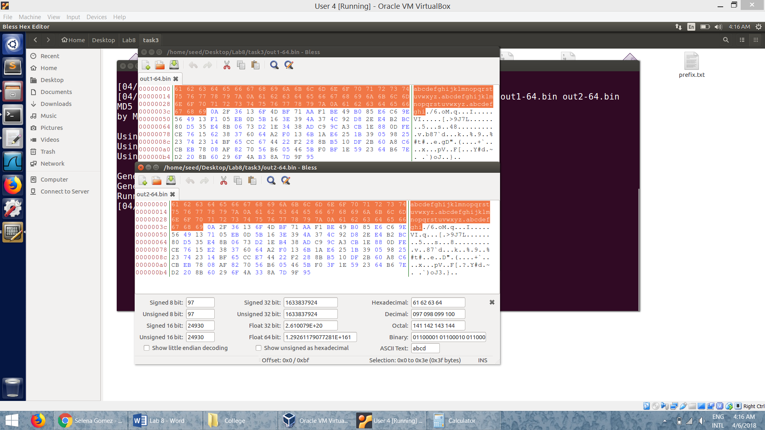

* The differences in the two output files as seen in the *Bless:*

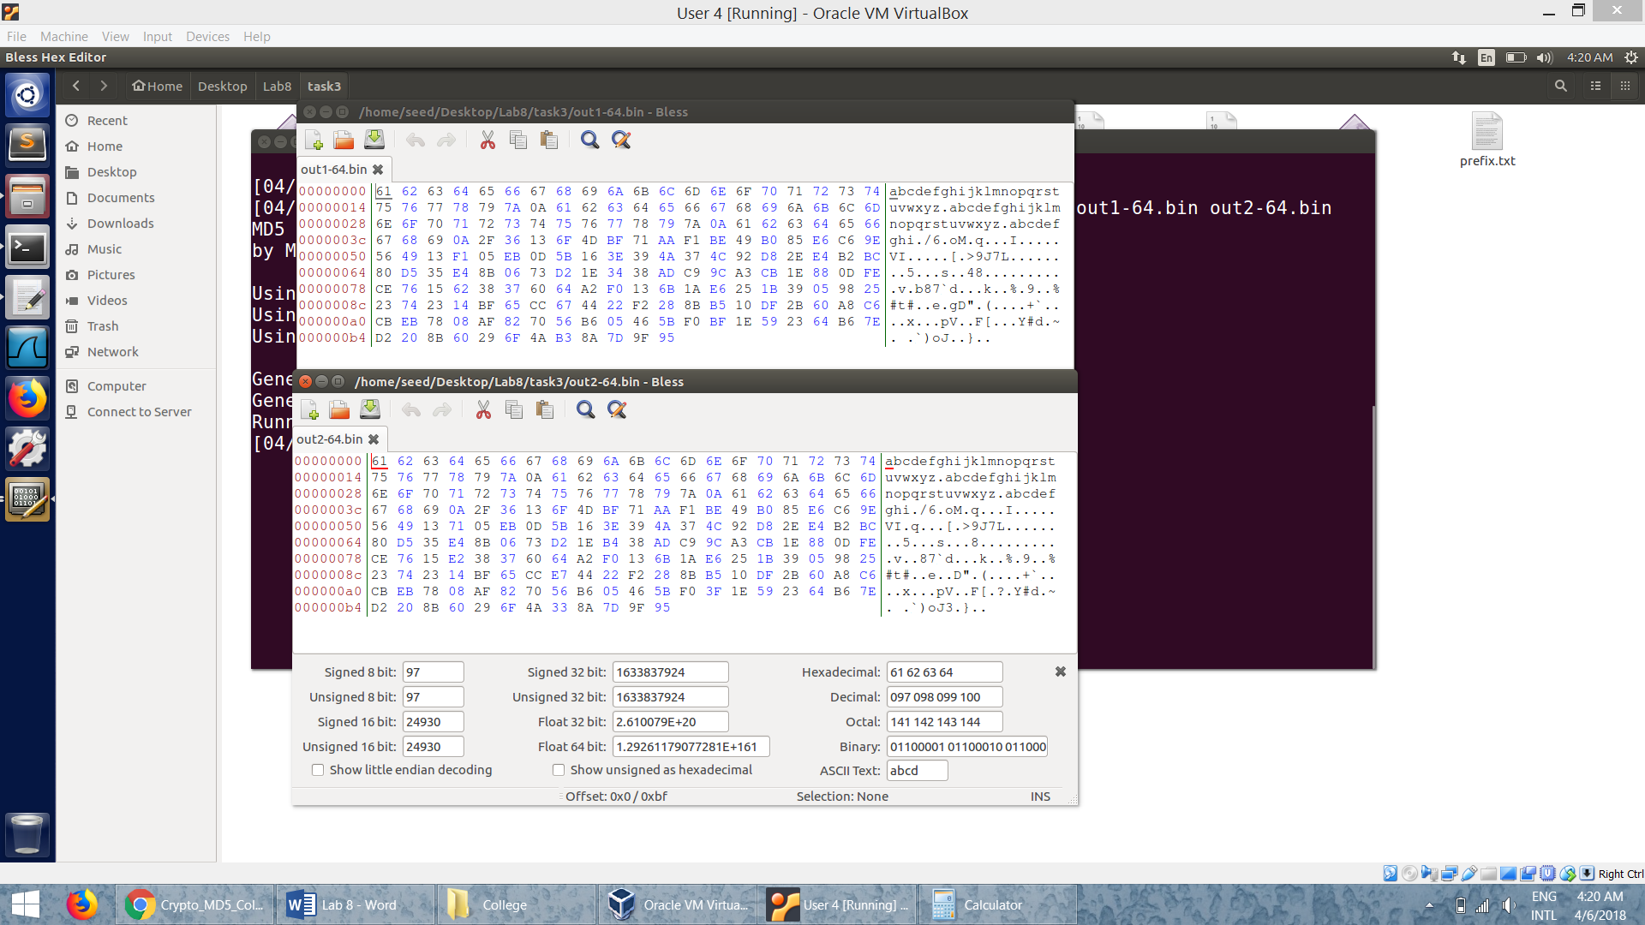

* We can also see that the two output files are different using the *diff*  command:



* But from the MD5 hash produced by the md5sum command. We can see that their MD5 hash values are the same

**Task 2: Understanding MD5’s Property**

* We run the md5collgen program generating two output files M.txt and N.txt:

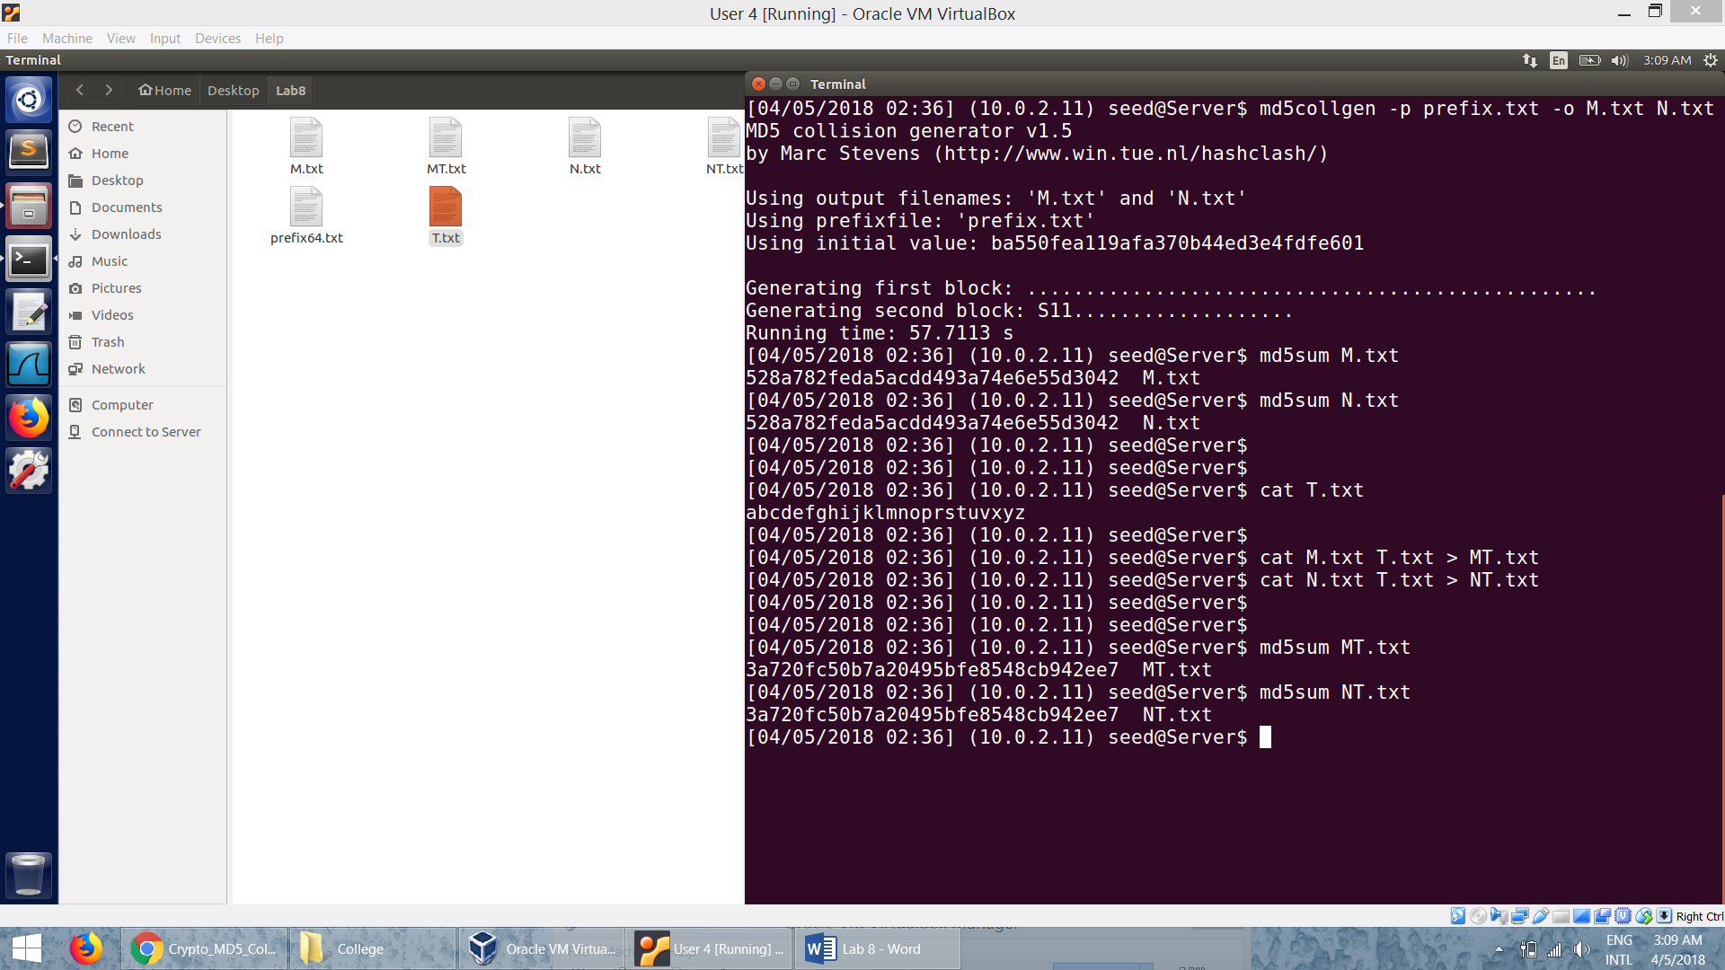

* We can see that the MD5 hash values of these two files are the same:



* We can see that even after concatenating a file T.txt to these two files, the MD5 hash value of the new files will be equal:



* Hence we can conclude that,

Given two inputs M and N, if MD5(M) = MD5(N), i.e., the MD5 hashes of M and N are the same, then for any input T, MD5(M || T) = MD5(N || T), where || represents concatenation.

**Task 3: Generating Two Executable Files with the Same MD5 Hash**

* The code:

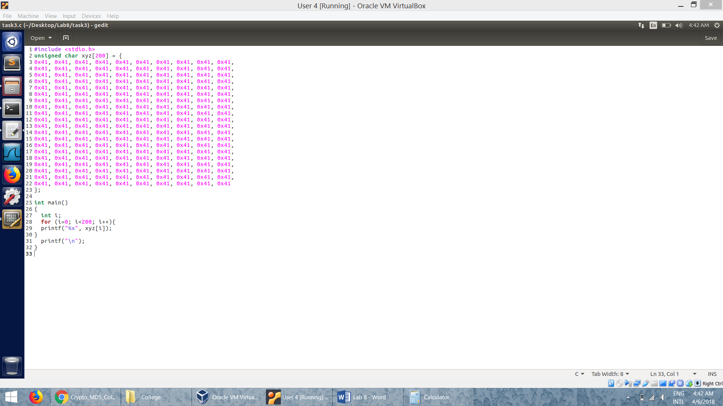

* The array *xyz* is filled with 200 A’s so that we can locate it easily in the hex file.
* We run the code to obtain the executable:

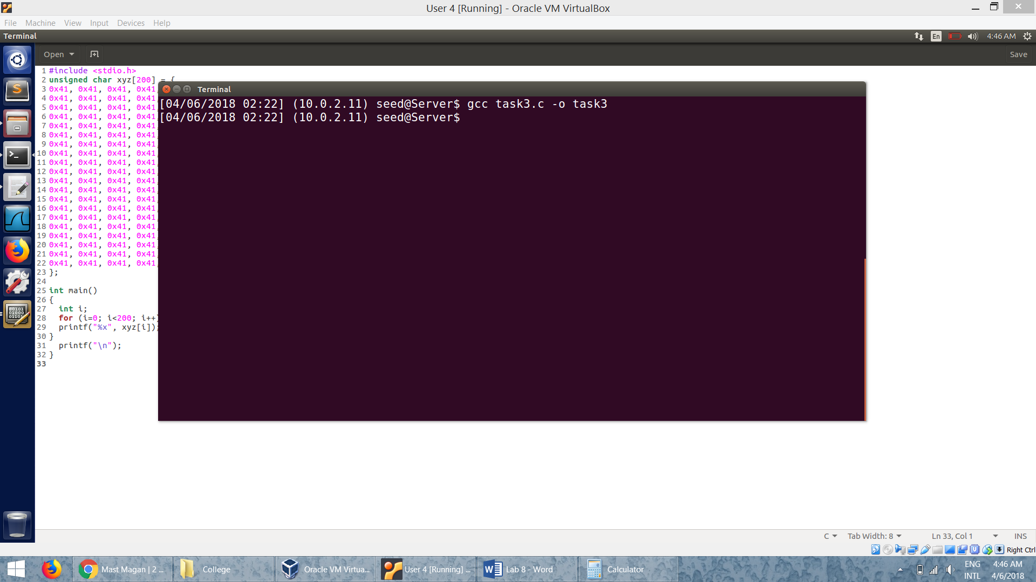

* Seeing the executable *task3* in *Bless* editor:

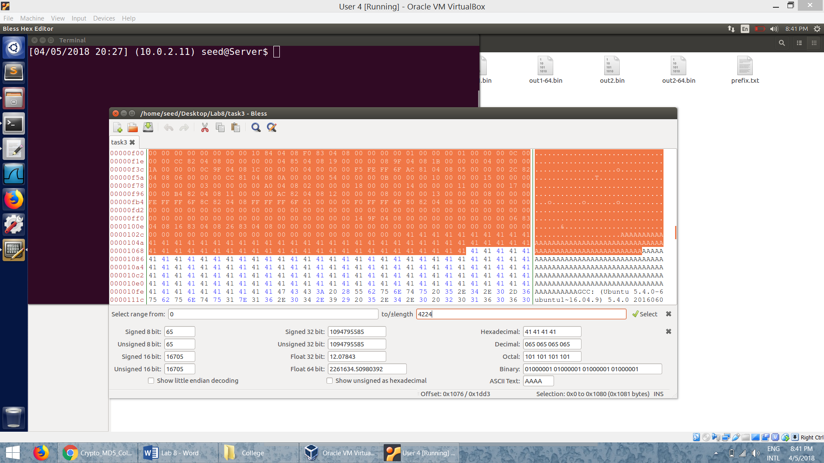

* We then take a offset of the file including some content of the array.
* The following head command takes first 4224 (multiple of 64) and save it to file prefix.
* Then we skip 128 bytes and take the content from the offset 4224+128 = 4352 to end of the file and save it suffix.

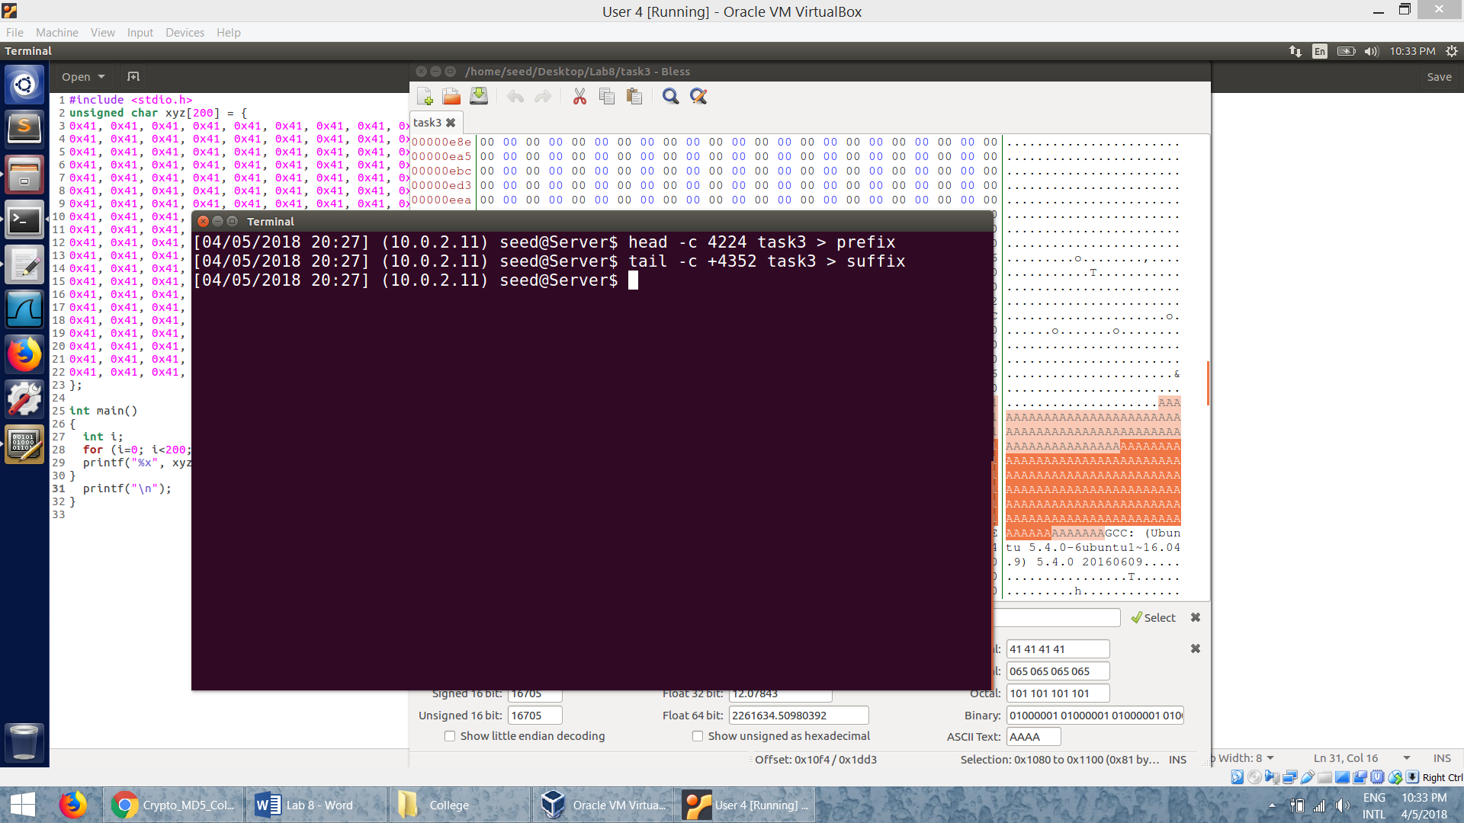

* Then we run the md5collgen program to obtain two output files:

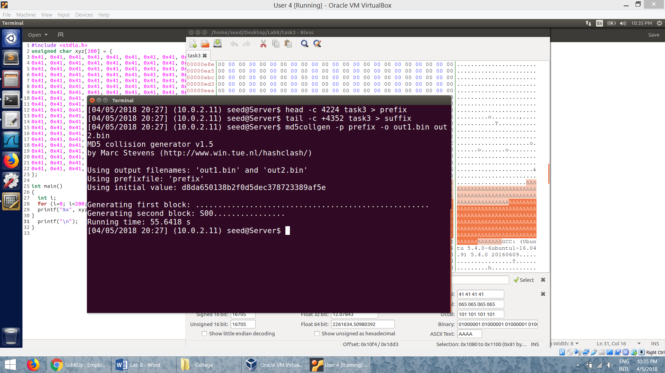

* The last 128 bytes from the two output files:

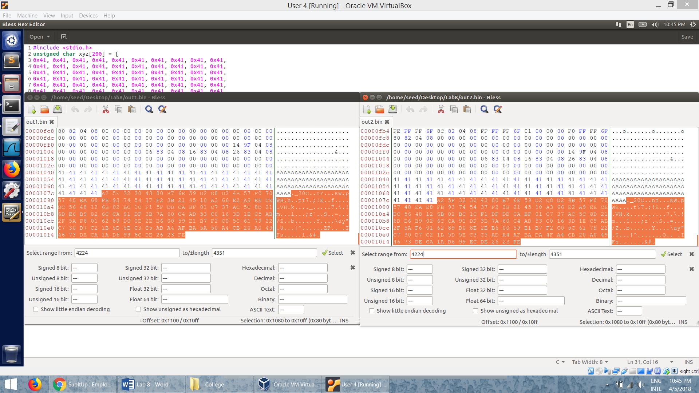

* We then take out the last 128 bytes from these two files and save them in P and Q:

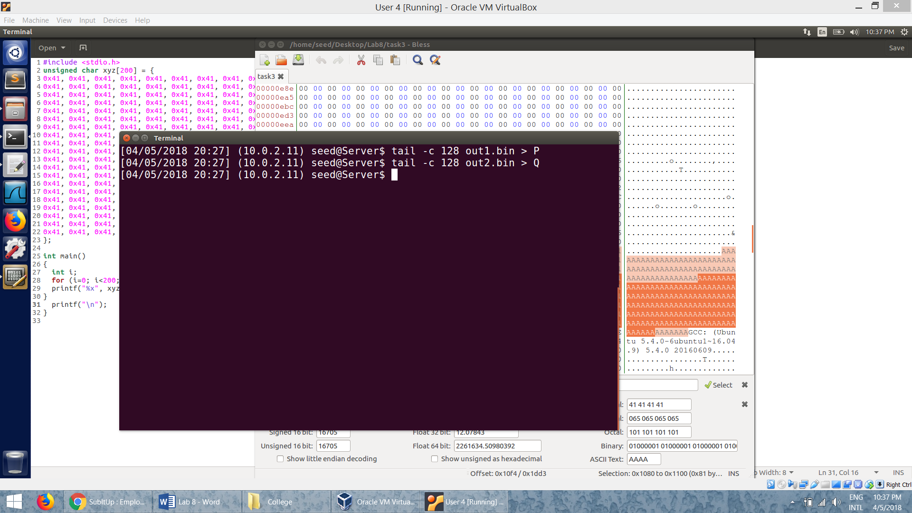

* Now, we concatenate the prefix, P and suffix to form the first program a1.out.
* And we concatenate the prefix, Q and suffix to form the second program a2.out.

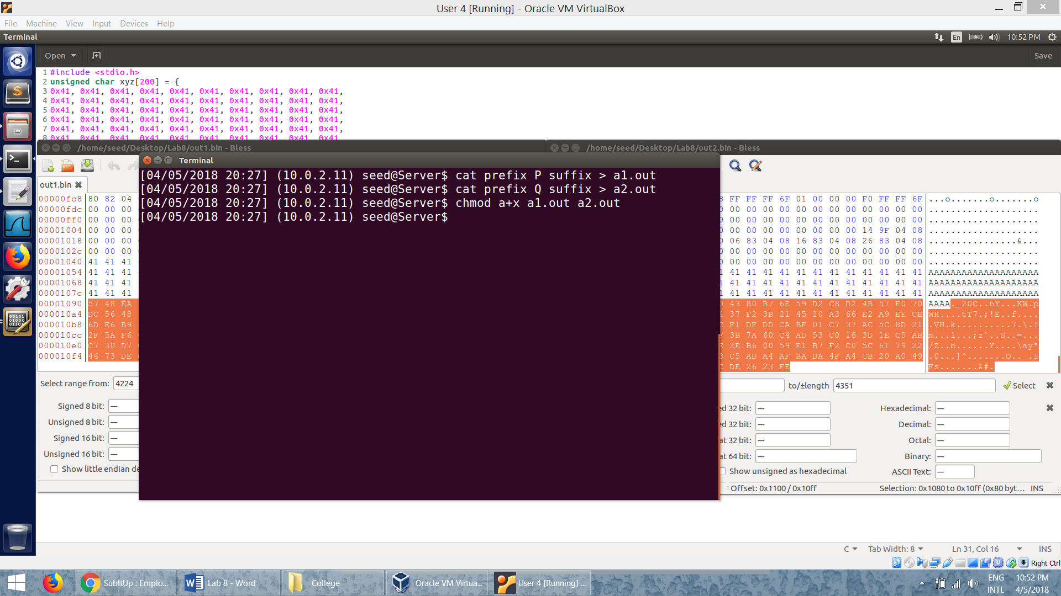

* From the *diff*  command we can see that the two programs are different but their MD5 hash values are same:

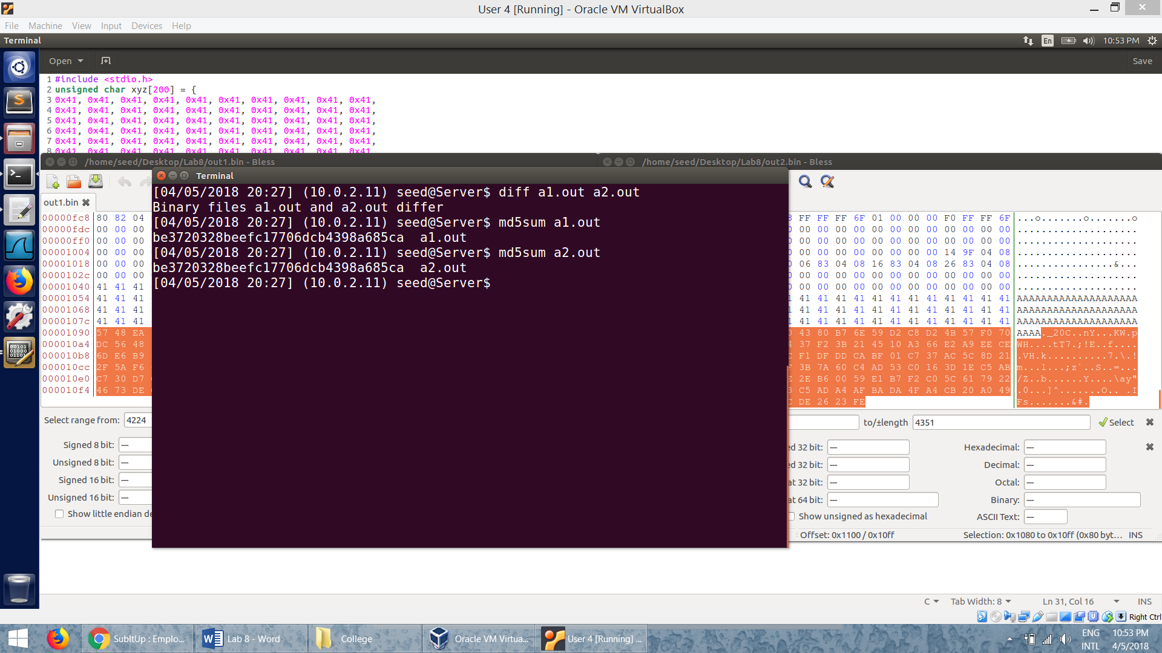

* We now run the two programs.

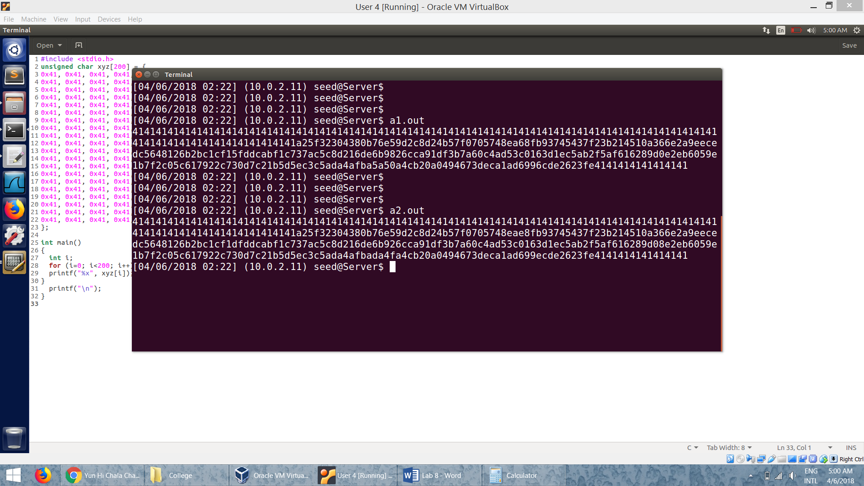

* Since we changed only the contents of their arrays and not their code, the program will run without a problem. They both print the contents of their arrays. The outputs look similar because P and Q differ only by a few bits. Still, we can see notice some difference in the output (one such difference is shown).

**Task 4: Making the Two Programs Behave Differently**

* The code:

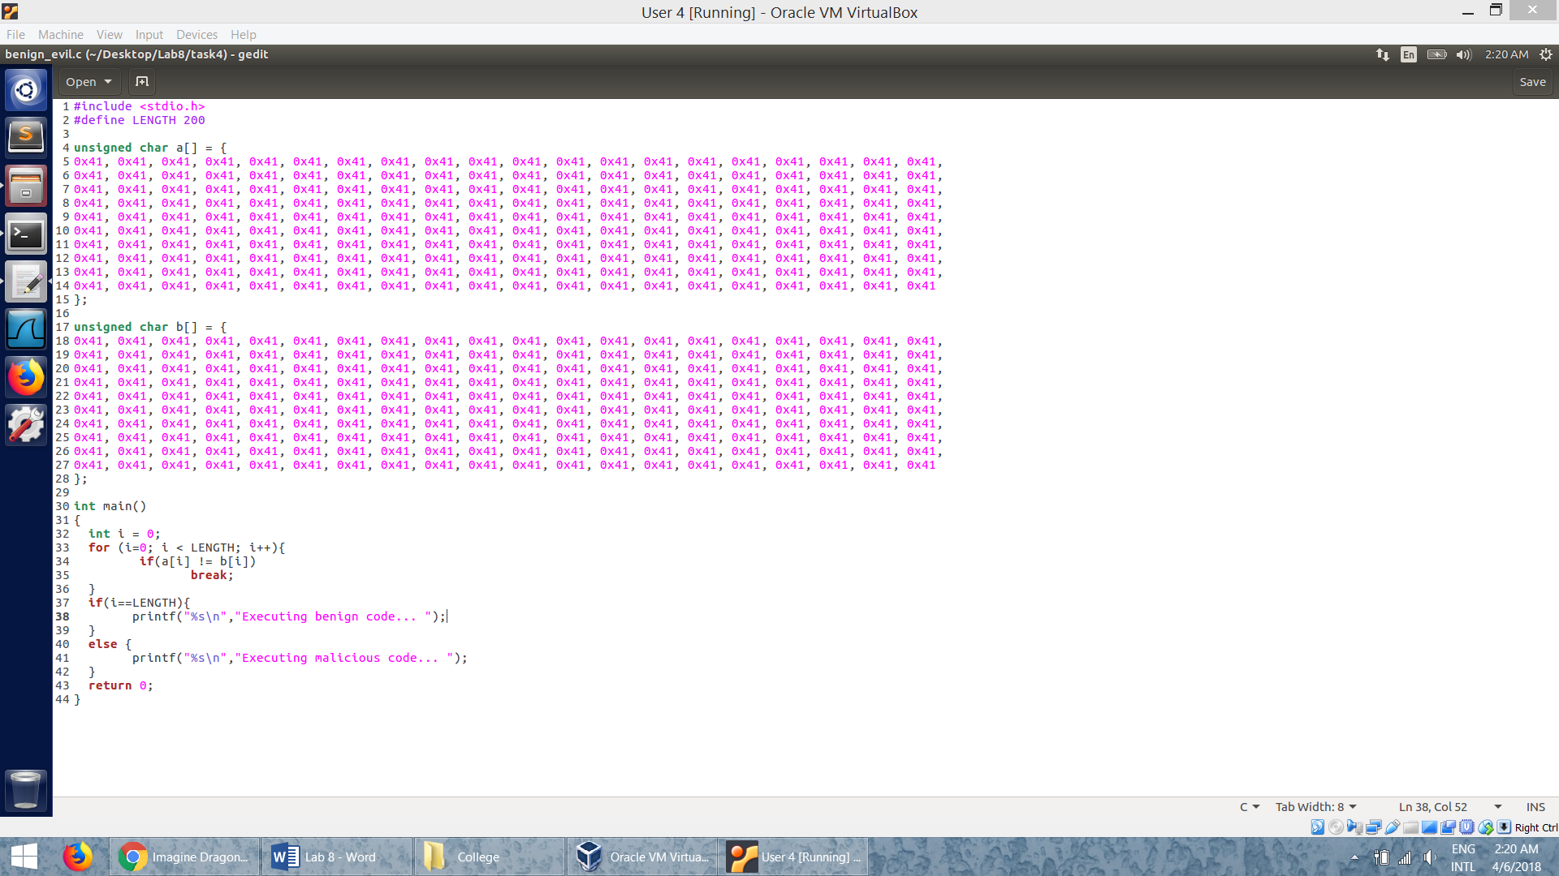

* The code has two branches. If the contents of the arrays are same, the program runs the benign code, otherwise it runs the malicious code.
* We compile the code and get the exectuble a.out.
* The contents of the executable file.

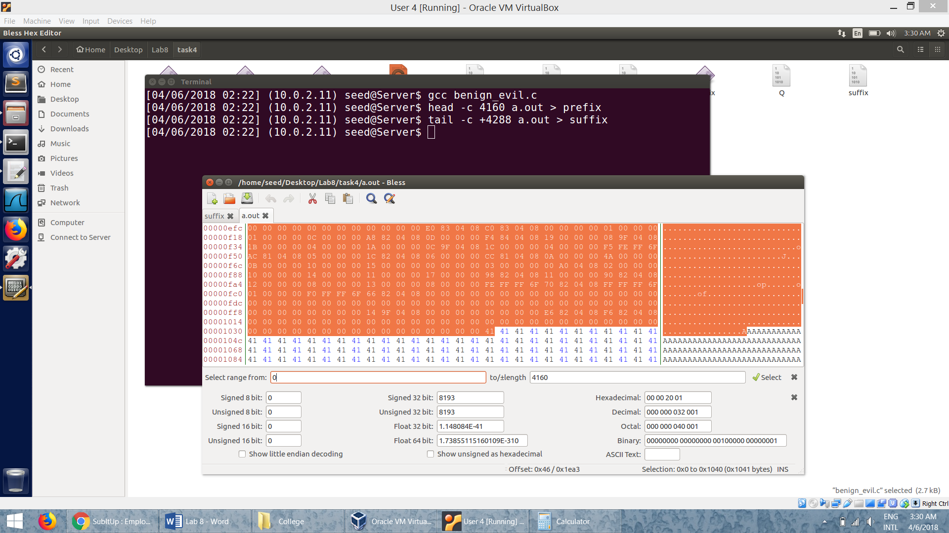

* Similar to the task 3, we divide the contents into prefix and suffix.
* The first 4160 bytes goes to the prefix and from 4288th (4160+128) byte to the end of the file goes to suffix.

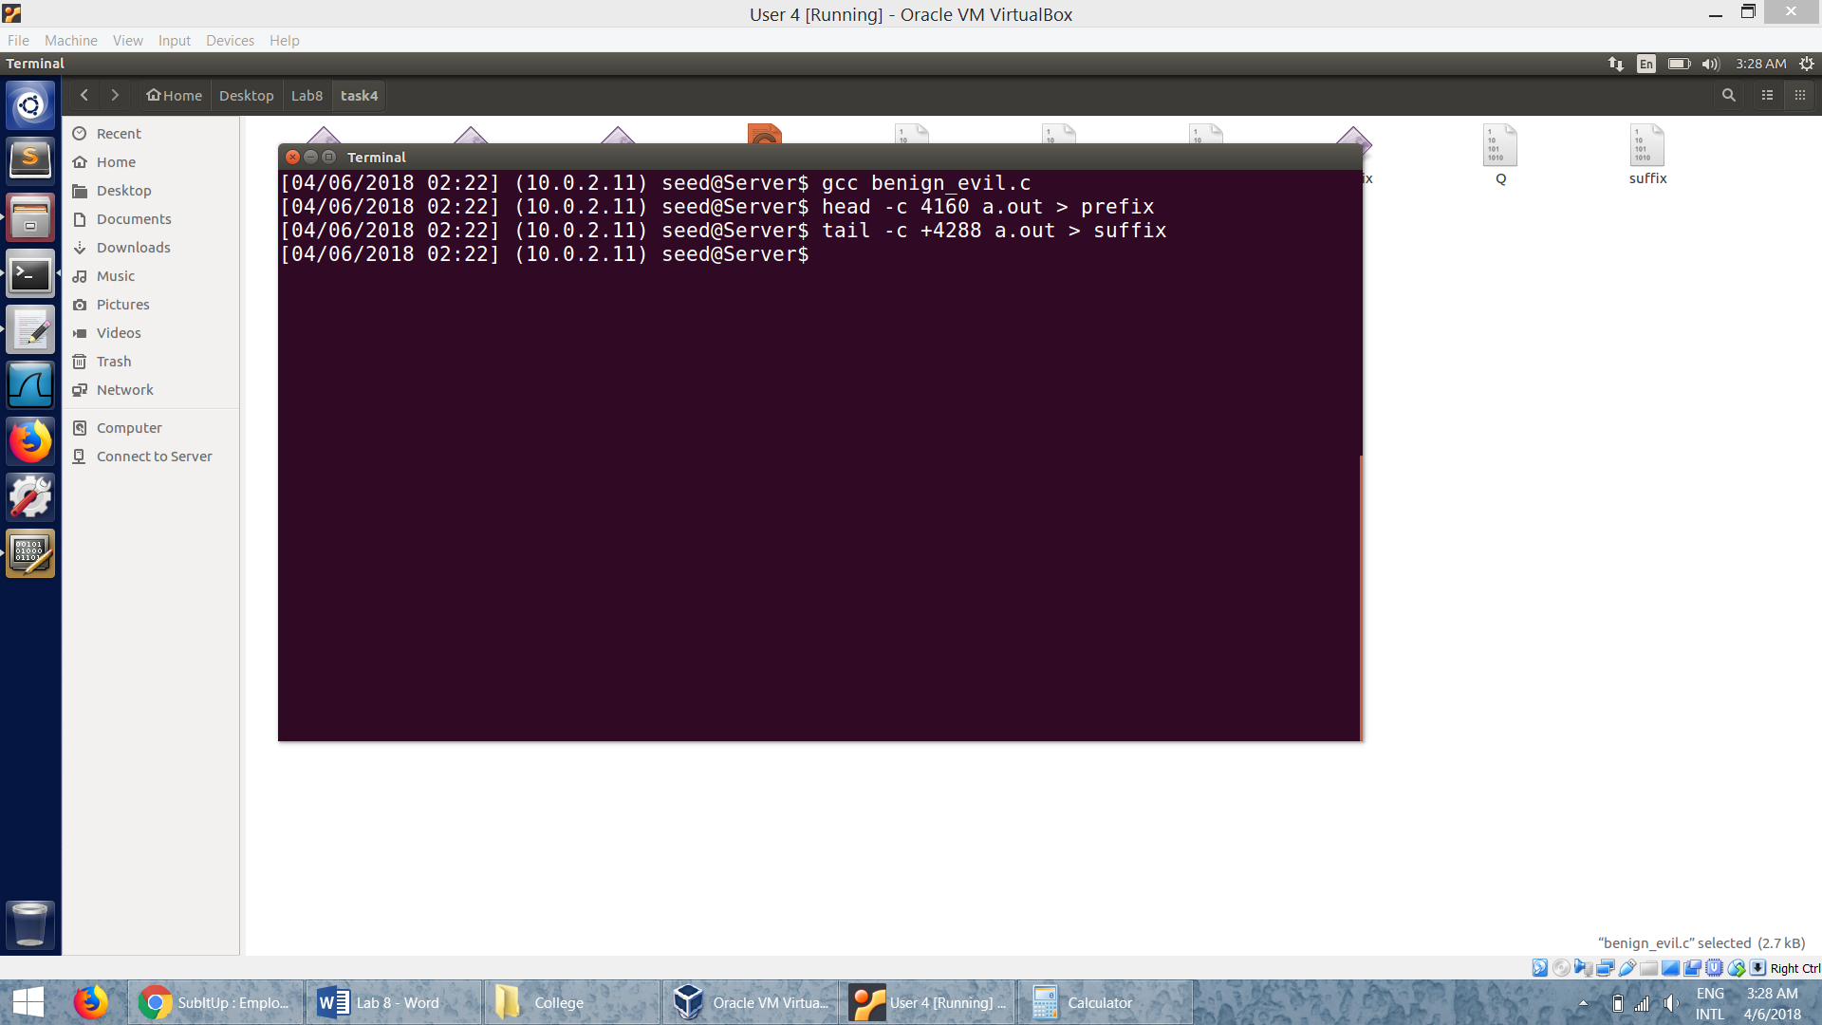

* We then run the md5collgen program and save the last 128 bytes of the output files to P and Q respectively.

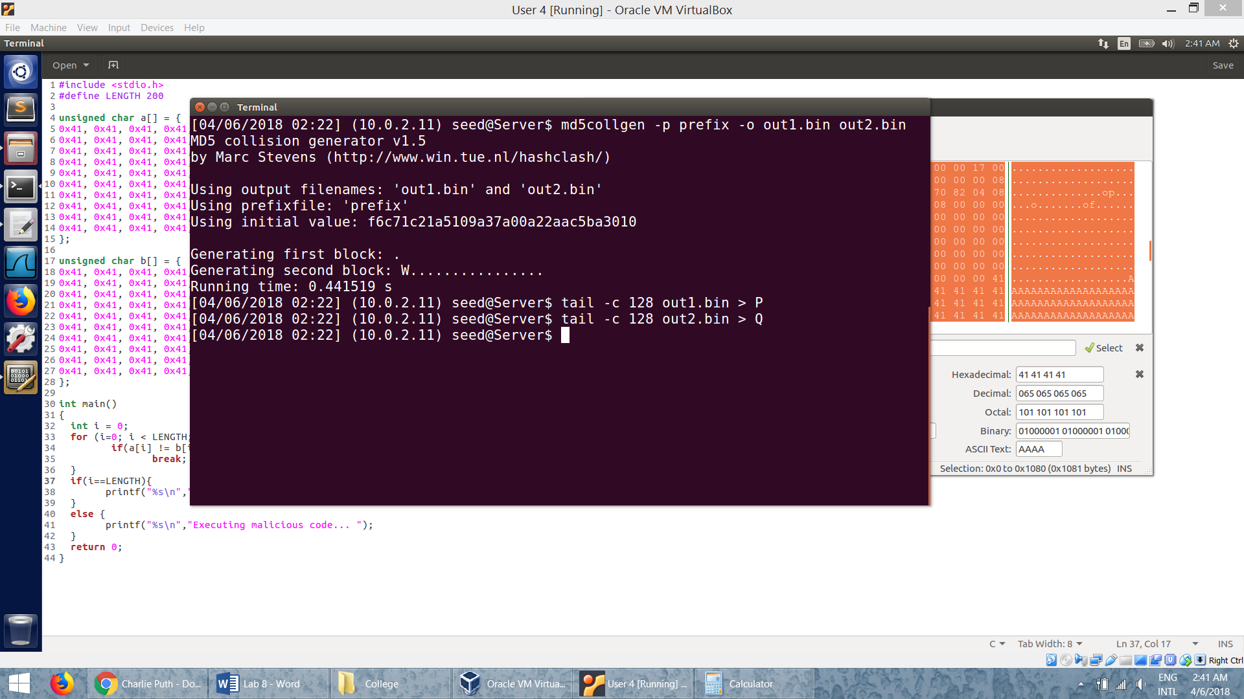

* Viewing the suffix file:

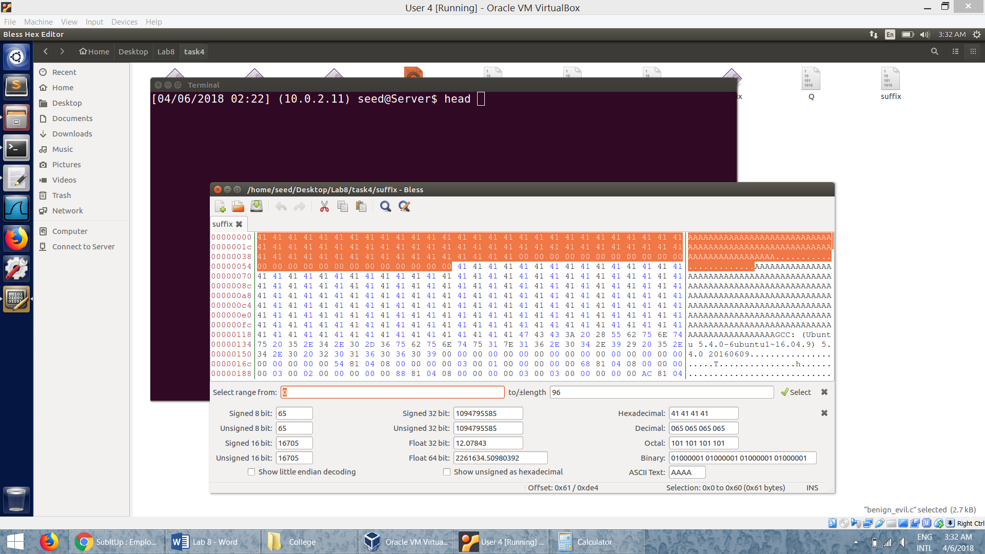

* We further break the suffix into two parts. The first part before P is placed and another one after P.
* In our program, the first part of the suffix is the first 96 bytes.
* So the second part will be from offset 224 (96+128) to the end of the file.

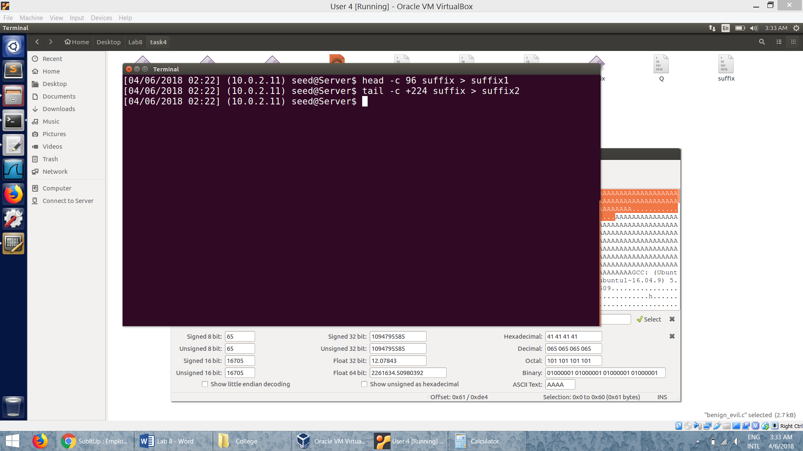

* Now, we concatenate everything together:
* We construct *a1.out* using: *Prefix, P, suffix1, P, suffix2*
* We construct *a2.out* using: *Prefix, Q, suffix1, P, suffix2*
* We run these two programs.

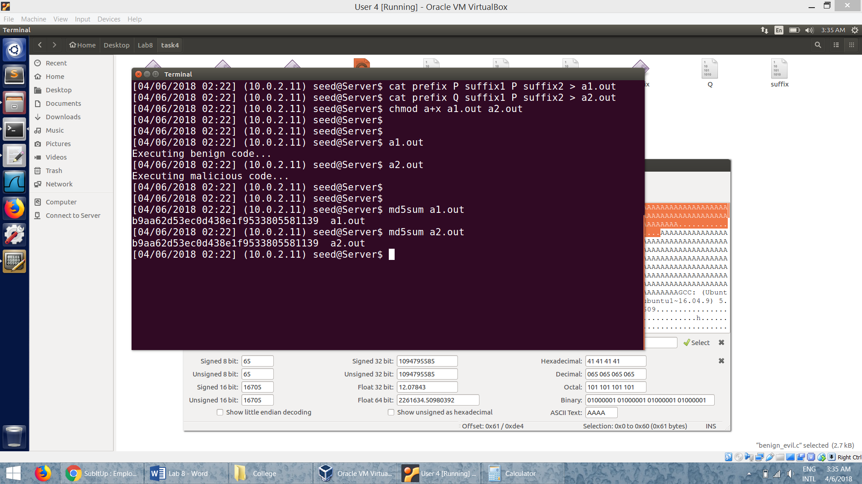

* We can see that one goes to benign branch and other goes to malicious branch but their MD5 values are the same.